Name: Aidan Jones

Date: April 12, 2019

Course: CMPEN 472

email: [arj5190@psu.edu](mailto:arj5190@psu.edu)

HW10 Report

Title: Timer module and interrupt based Analog Signal Acquisition

Objective: CSE472 Homework 10

Programmer: Aidan Jones

Algorithm: waits for button 1 to be pressed to send data over SCI

Memory use: RAM locations from $3000 for data,

$3100 for program

Input: Parameters hard coded in program and SCI port

Output: HyperTerminal and Binary Data

Observation: This program takes the users input and sends hex or binary data

440Hz Sine Wave:

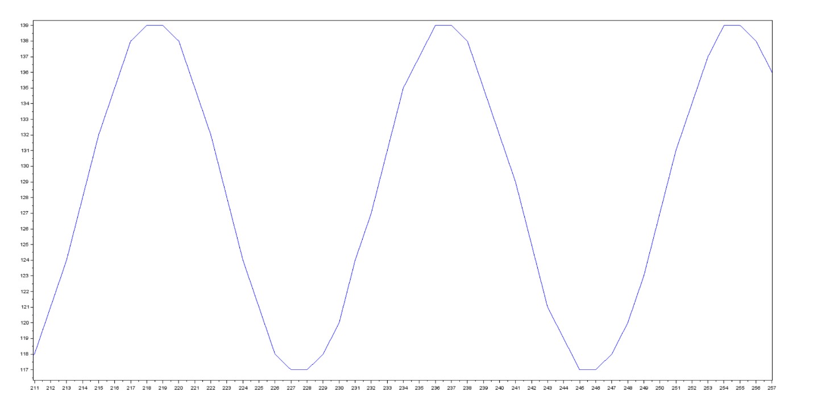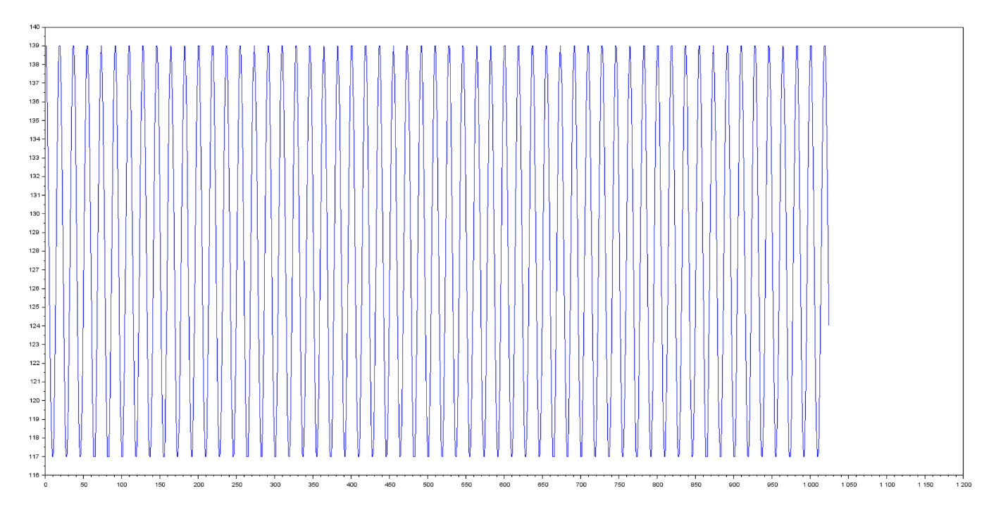

This is a sine wave at 440Hz with an 8KHz sample rate verified by the 18 samples taken over one period. The top picture shows two cycles of this wave with a third peeking in at the end.

8000Hz / 18 = ~444Hz

1000Hz Square Wave:

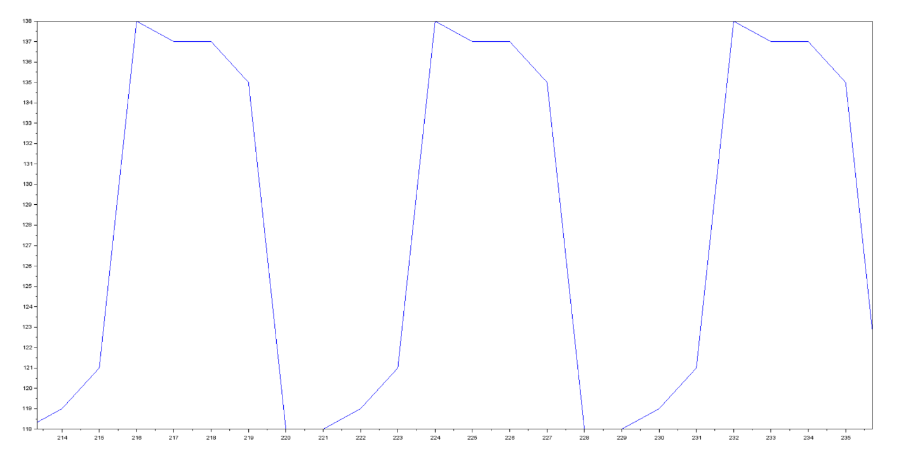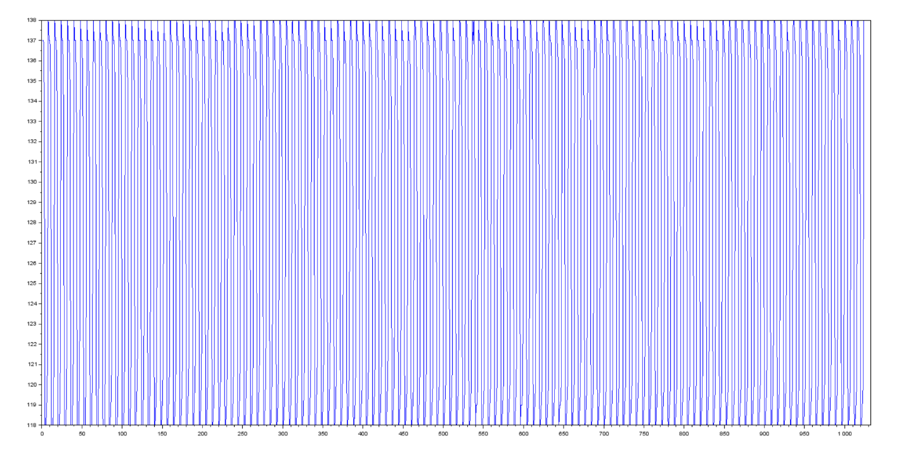

This is a square wave at 1000Hz with an 8KHz sample rate verified by the 8 samples taken over one period. The top picture shows three cycles of this wave, and only one point was cut off by the software but is still measurable due to the markings at the bottom.

8000Hz / 8 = 1000Hz

440Hz Triangle Wave:

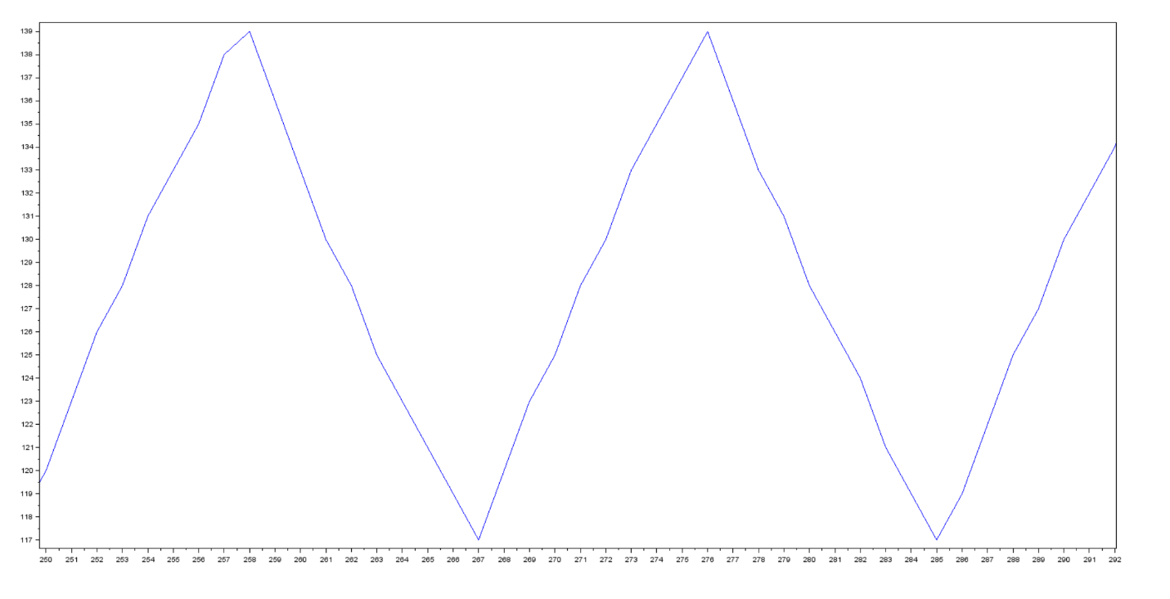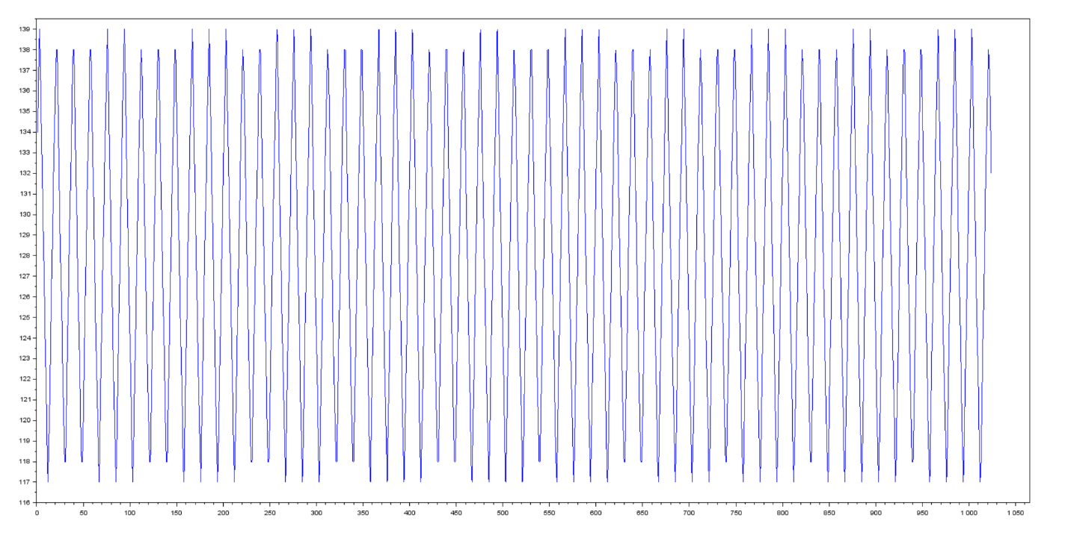

This is a triangle wave at 440Hz with an 8KHz sample rate verified by the 18 samples taken over one period, same as the 440hz sine wave. The top picture shows two cycles of this wave.

8000Hz / 18 = ~444Hz

440Hz/550Hz Mixed Sine Wave:

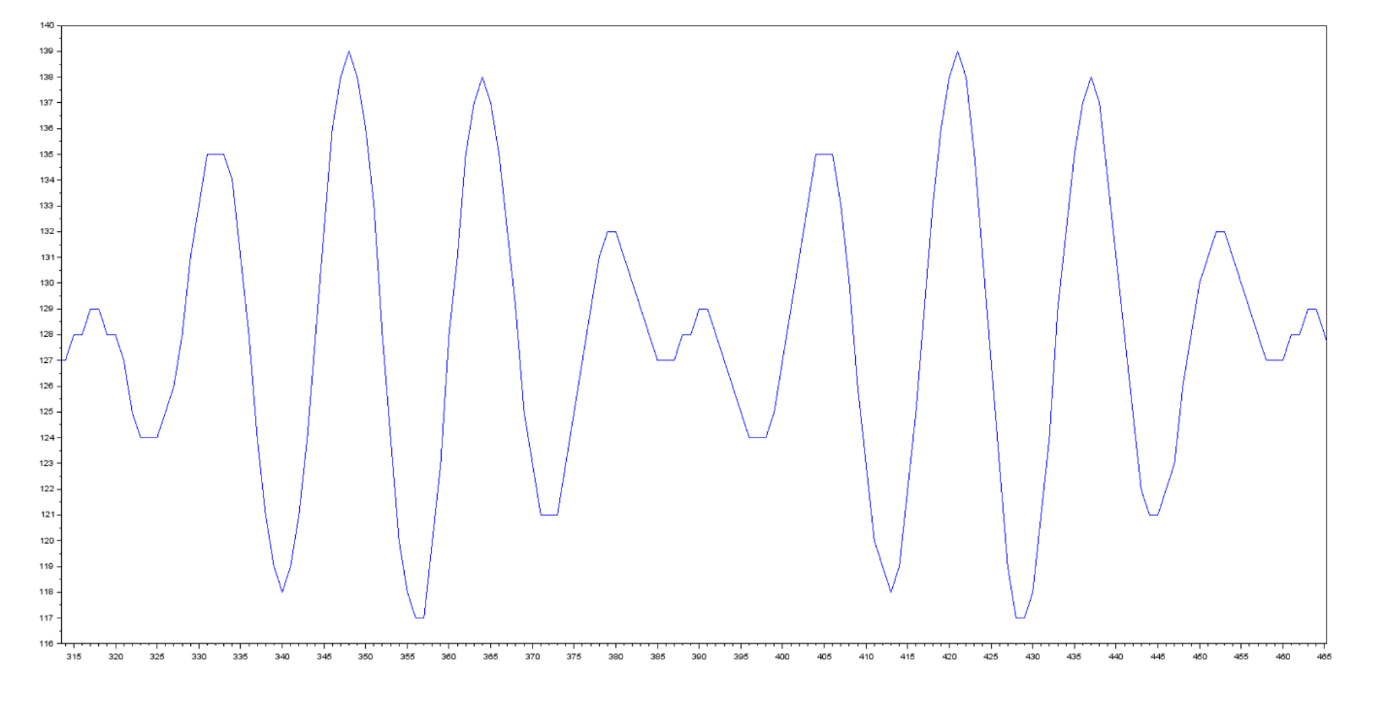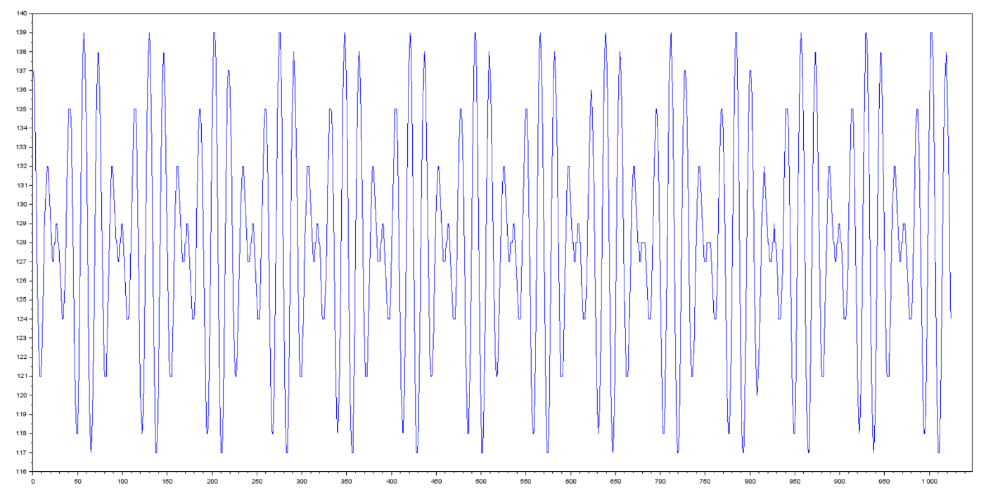  
This is a sine wave of two mixed sine waves at 440Hz and 550Hz with an 8KHz sample rate verified by the 12 samples taken over one period, same as the 440hz sine wave. The top picture shows two cycles of this wave.

8000Hz / 12 = ~666Hz